

**1.Title of the Project:**

**Facial expression recognition system**

**2. Introduction :**

Face detection -- also called facial detection -- is an [artificial intelligence](https://www.techtarget.com/searchenterpriseai/definition/AI-Artificial-Intelligence) (AI) based computer technology used to find and identify human faces in digital images. Face detection technology can be applied to various fields -- including security, [biometrics](https://www.techtarget.com/searchsecurity/definition/biometrics), law enforcement, entertainment and personal safety -- to provide surveillance and tracking of people in real time.

**3. Objective of the project:**

The objective of face recognition is, from the incoming image, **to find a series of data of the same face in a set of training images in a database.** The great difficulty is ensuring that this process is carried out in real-time, something that is not available to all biometric face recognition software providers.

**4. Scope of the project:**

Facial recognition systems can be used to **identify people in photos, videos, or in real-time**. Facial recognition is a category of biometric security.

**5. Project category:**

Computers can use machine vision technologies in combination with a camera and **artificial intelligence software** to achieve image recognition.

**6. Hardware:**

PC, Mac or laptop with**(64-bit)** compatible processors.

* + 2 GHz or better processor is recommended.
  + At least **512 MB of free RAM**.
  + 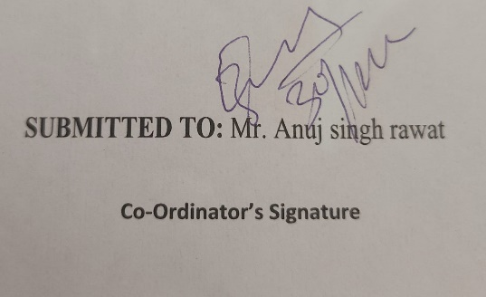A **camera or webcam**

**7. Software:**

* Python, OpenCV, Pycharm